Date: 12-10-21
WEBLEM 7
Introduction of Structure Database

The Protein Data Bank (PDB) at Brookhaven National Laboratory (BNL), is a database containing experimentally determined three-dimensional structures of proteins, nucleic acids and other biological macromolecules (Abola et al., 1987, 1997; Bernstein et al., 1977).
The PDB has a 26-year history of service to a global community of researchers, educators and students in a wide variety of scientific disciplines.
The archives contain atomic coordinates, citations, primary and secondary structure information, crystallographic structure experimental data, as well as hyperlinks to many other scienti®c databases.
Scientists around the world contribute structures to the PDB and use it on a daily basis. The common interest shared by this community is a need to access information that can relate the biological functions of macromolecules to their three-dimensional structures.
RCSB PDB (Research Collaboratory for Structural Bioinformatics PDB) operates the US data center for the global PDB archive, and makes PDB data available at no charge to all data consumers without limitations on usage (Policies).

Observations:
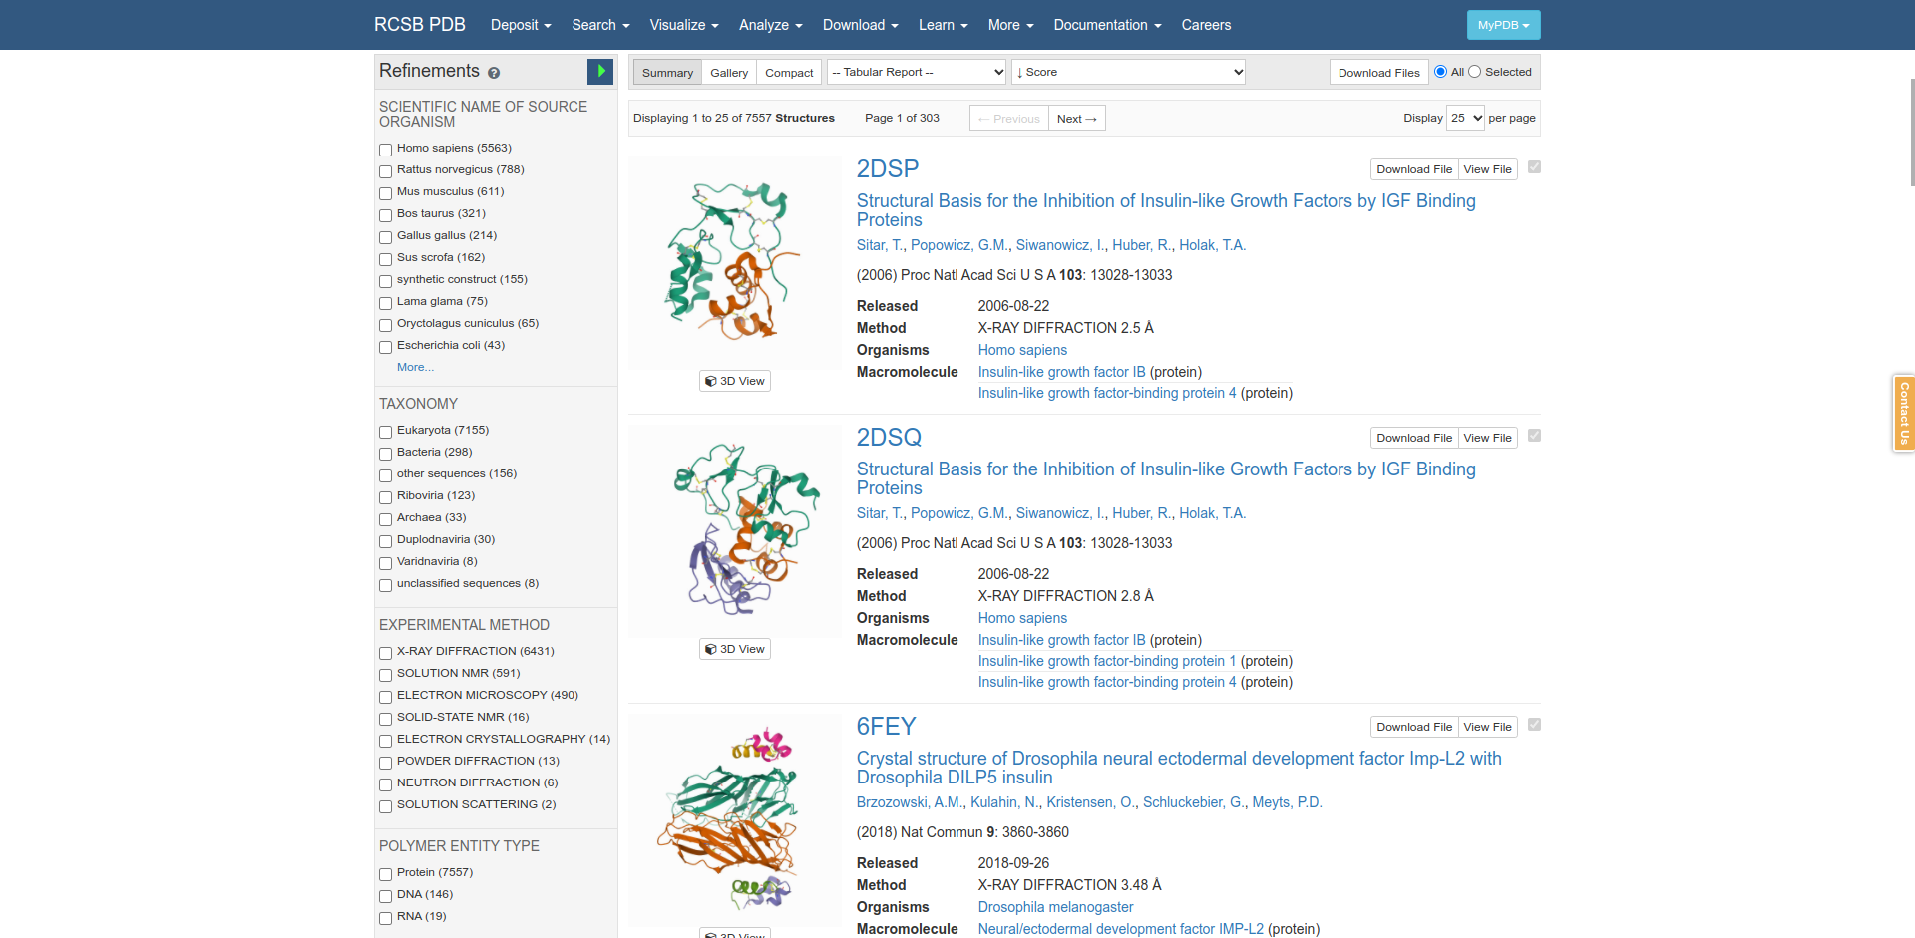
Fig1. Summary form in PDB Database

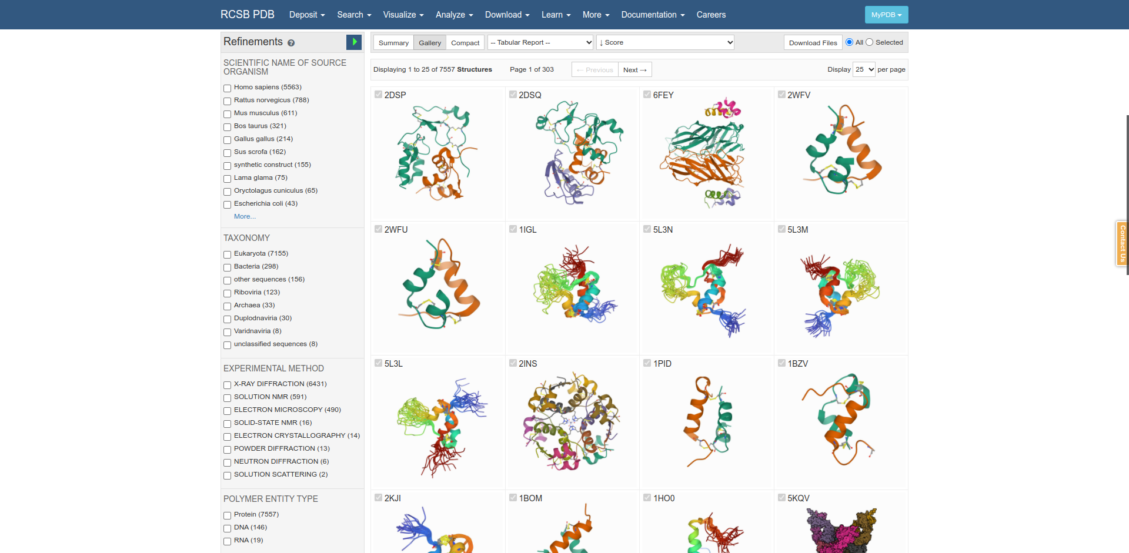
Fig2. Gallery form in PDB database

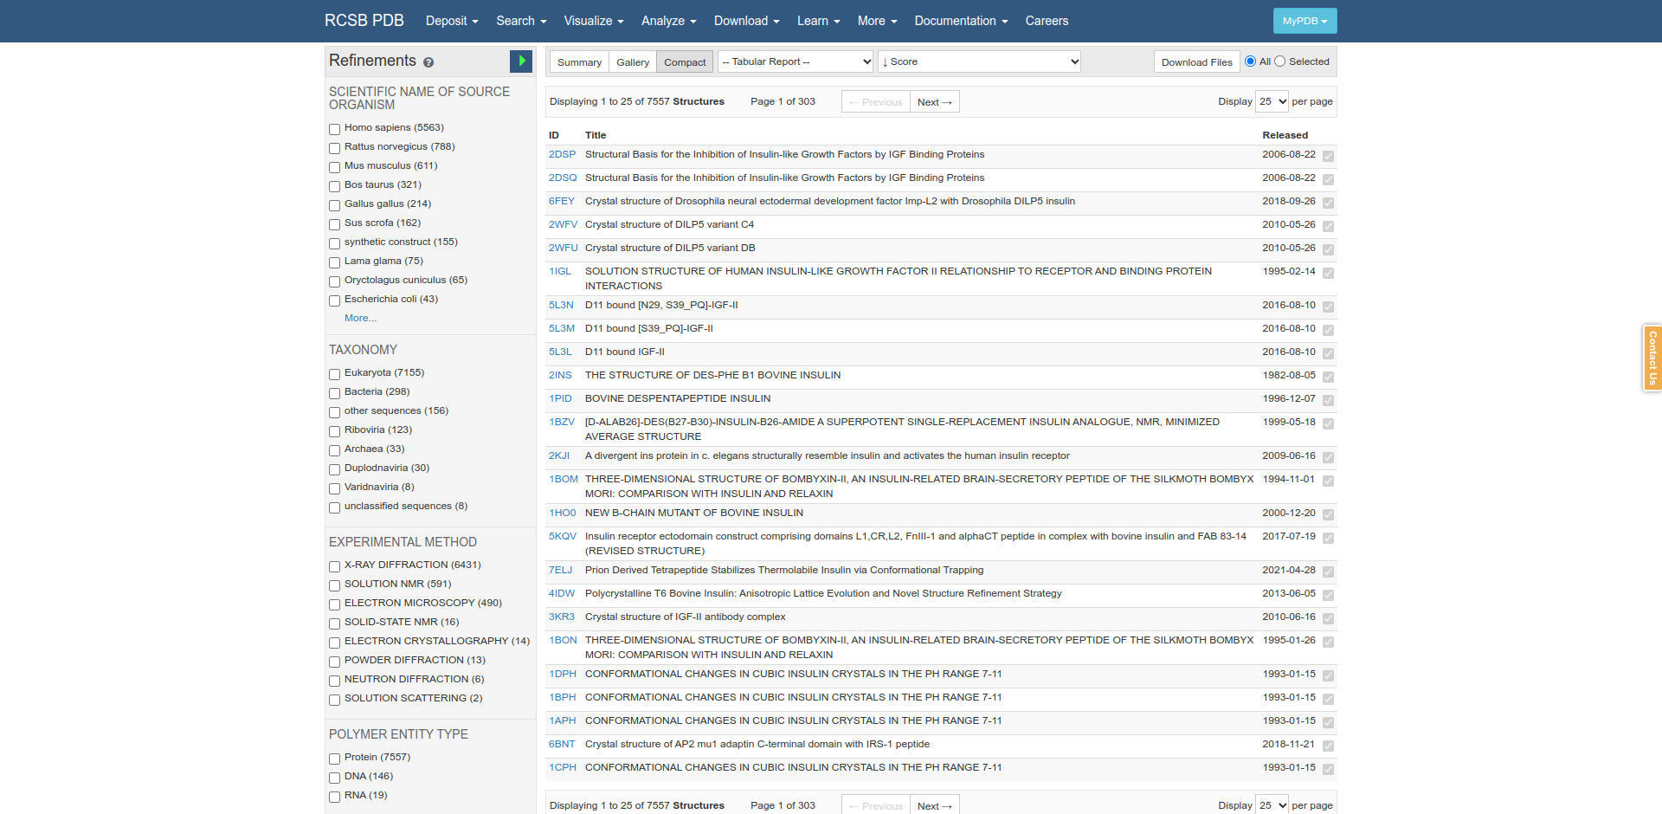
Fig3. Compact form in PDB database

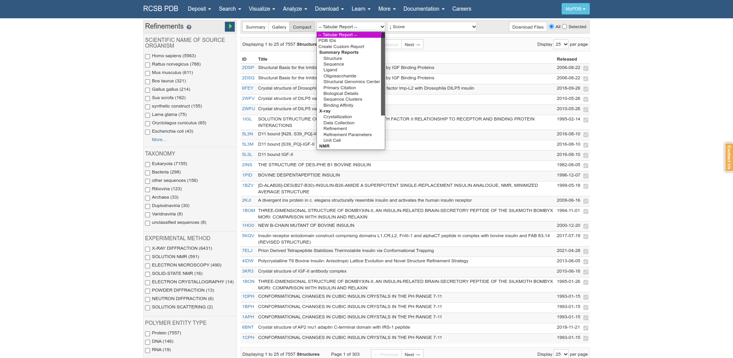
Fig4. Tabular Report form in PDB Database

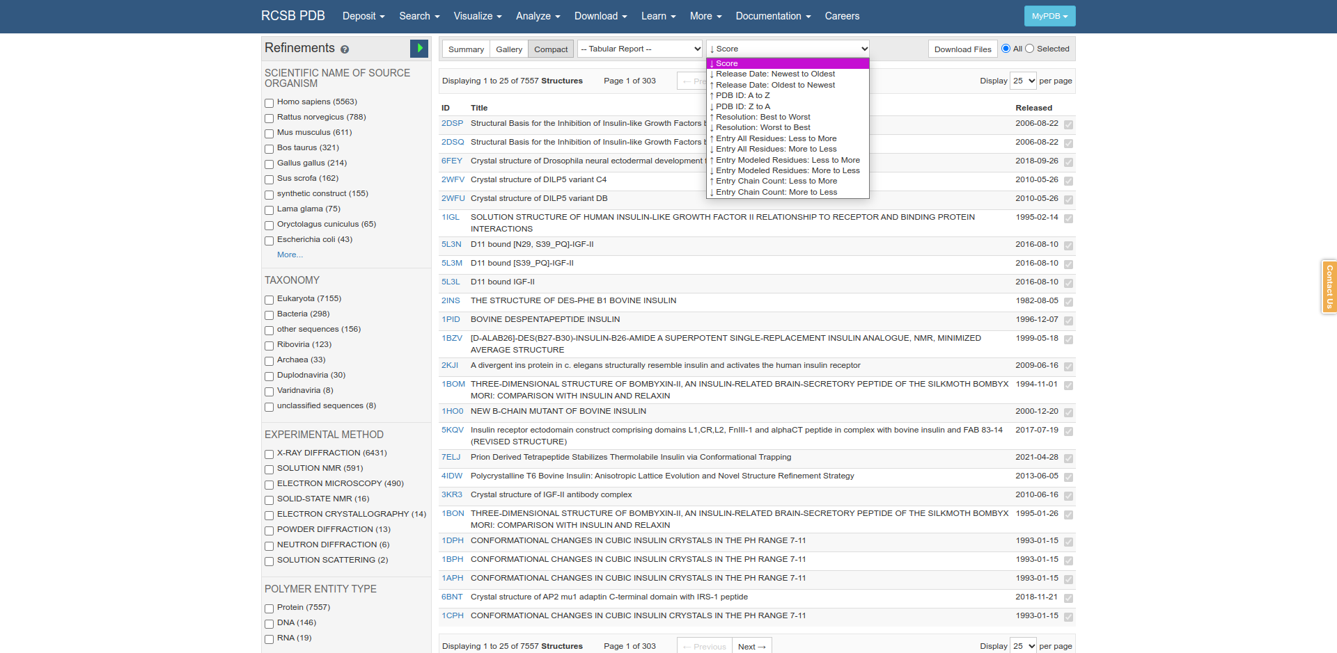
Fig5. Score form in PDB Database.

References:
- Sussman, J. L., Lin, D., Jiang, J., Manning, N. O., Prilusky, J., Ritter, O., & Abola, E. E. (1998). Protein Data Bank (PDB): Database of Three-Dimensional Structural Information of Biological Macromolecules. Acta Crystallographica Section D Biological Crystallography, 54(6), 1078–1084. https://doi.org/10.1107/s0907444998009378
- Bank, R. P. (n.d.). Homepage. Retrieved from https://www.rcsb.org/

Date: 12-10-21
WEBLEM 7a
(URL: https://www.rcsb.org/)

Aim:
To study “Insulin” Query in Structure Database PDB.

Introduction:
The Protein Data Bank (PDB) at Brookhaven National Laboratory (BNL), is a database containing experimentally determined three-dimensional structures of proteins, nucleic acids and other biological macromolecules (Abola et al., 1987, 1997; Bernstein et al., 1977).
The PDB has a 26-year history of service to a global community of researchers, educators and students in a wide variety of scientific disciplines.
The archives contain atomic coordinates, citations, primary and secondary structure information, crystallographic structure experimental data, as well as hyperlinks to many other scientific databases.

Insulin is a medication used in the treatment and management of diabetes mellitus type-1 and sometimes diabetes mellitus type-2, both of which are significant risk factors for coronary artery disease, stroke, peripheral vascular disease, and a host of other vascular conditions. This activity reviews the indications, contraindications, activity, adverse events, and other key elements of Insulin therapy in the clinical setting related to the essential points needed by members of an interprofessional team managing the care of patients with diabetes and its related conditions and sequelae.

Methodology:
- Open the Homepage of PDB.
- Enter the Query “Insulin”
- Open the Result page for the query
- Interpret the results.

Observation:
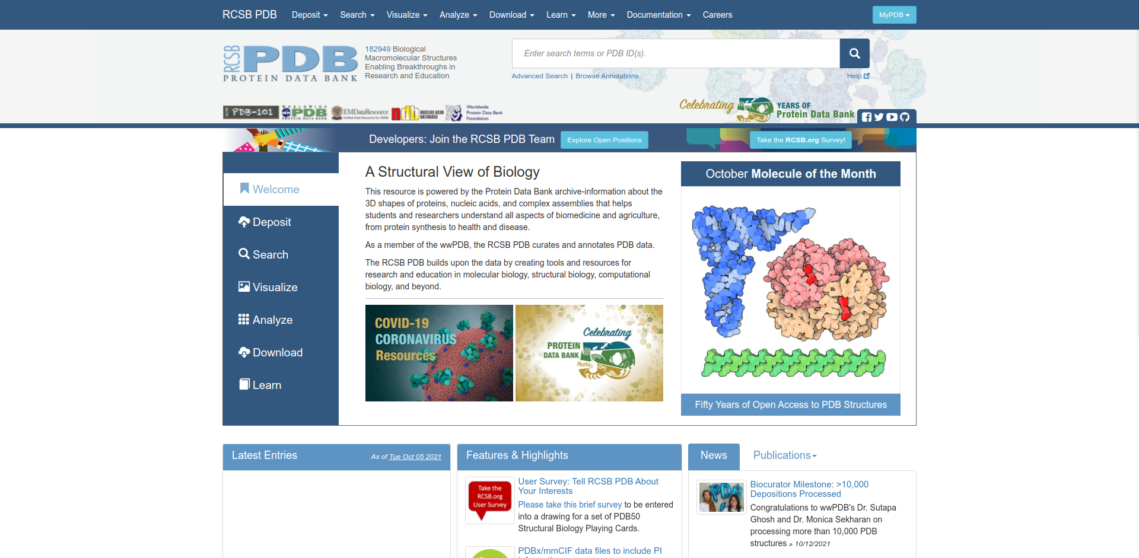
Fig1. Homepage of PDB Database

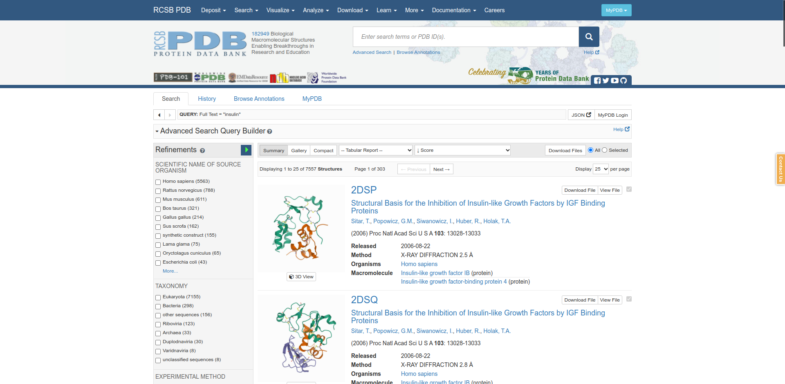
Fig2. Hitpage for query “Insulin”

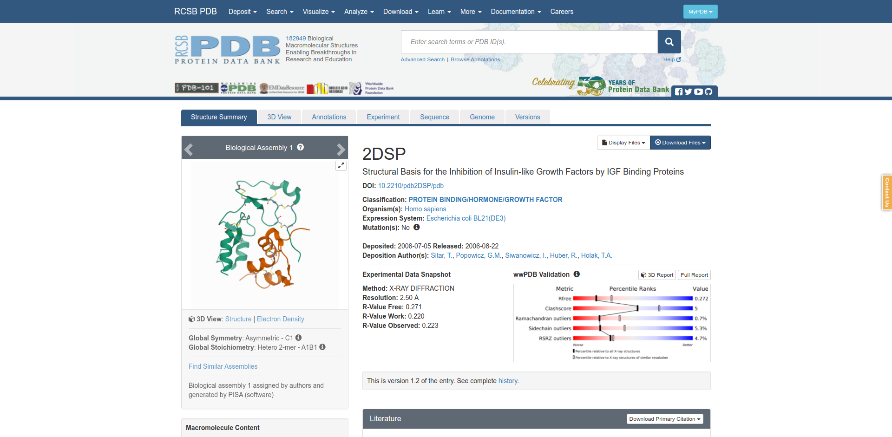
Fig3. Result page for query “Insulin”

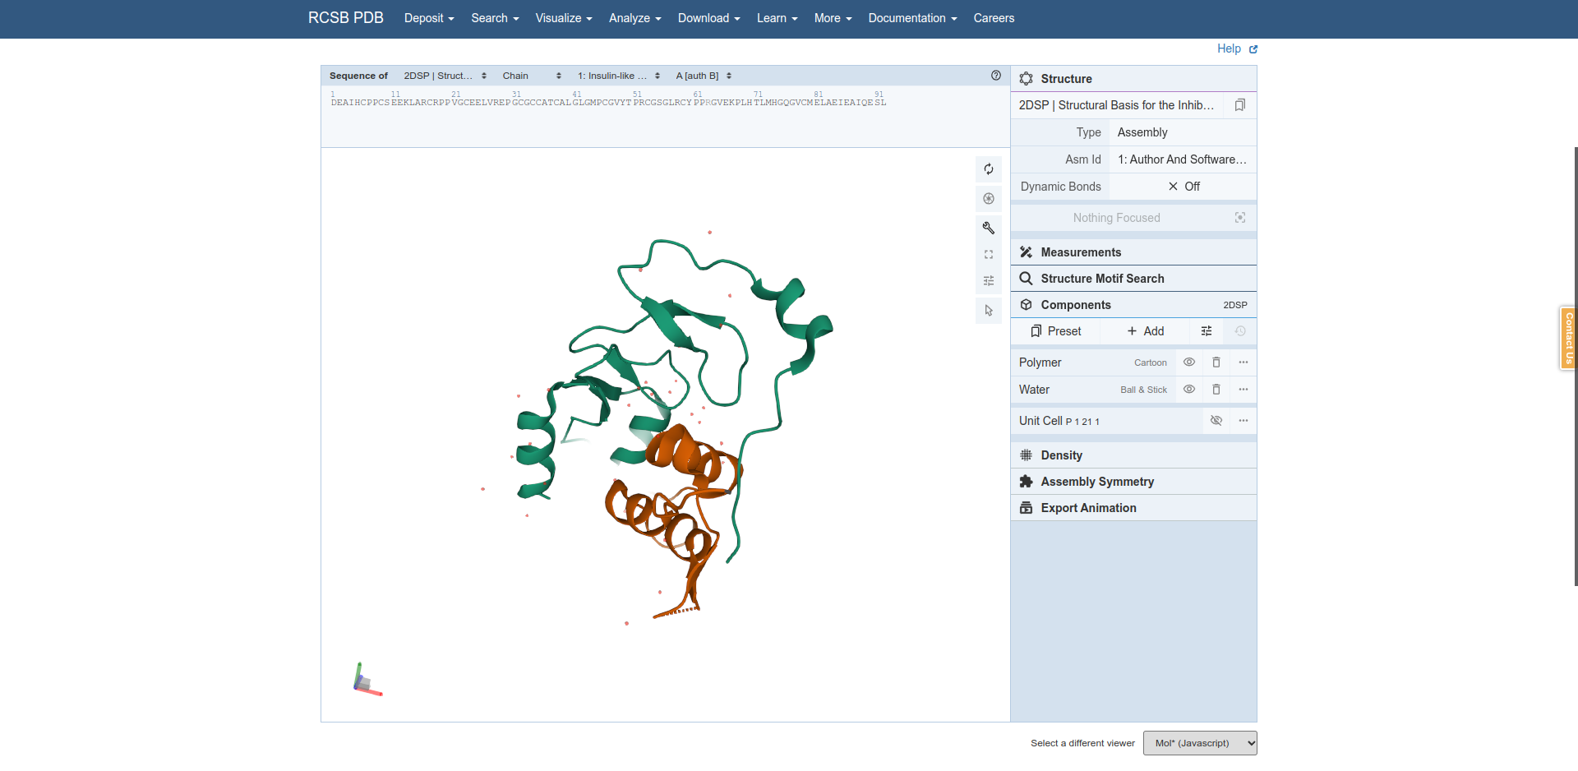
Fig4. 3D view for my Insulin.

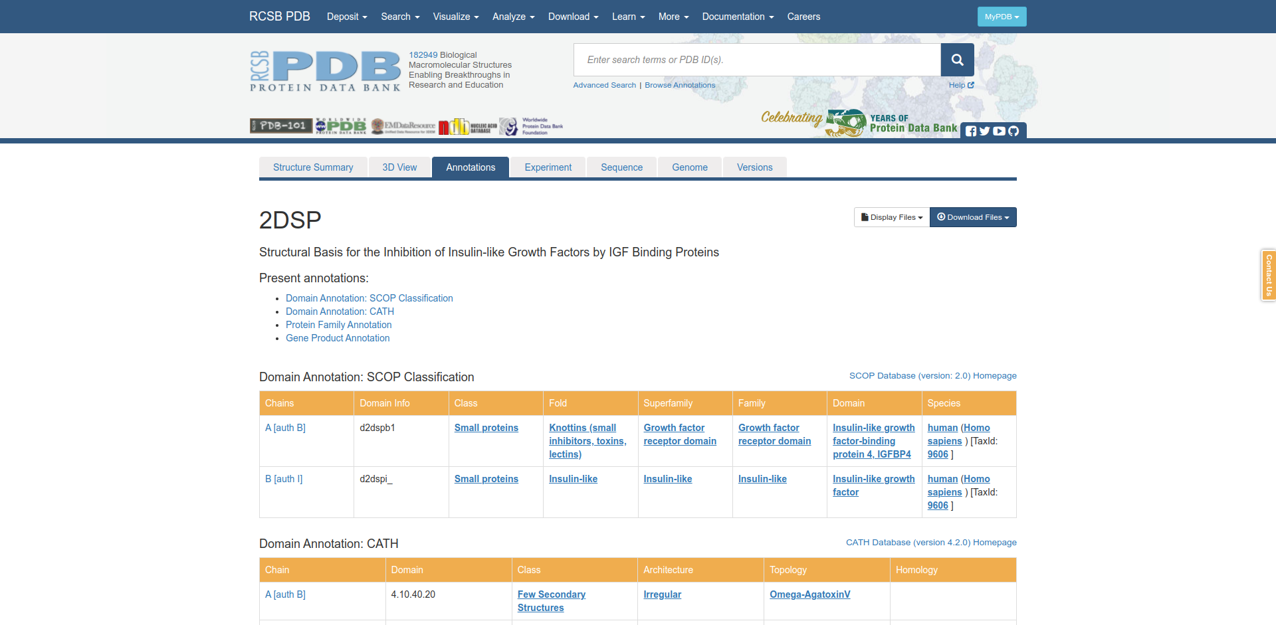
Fig5. Annotions for my query Insulin

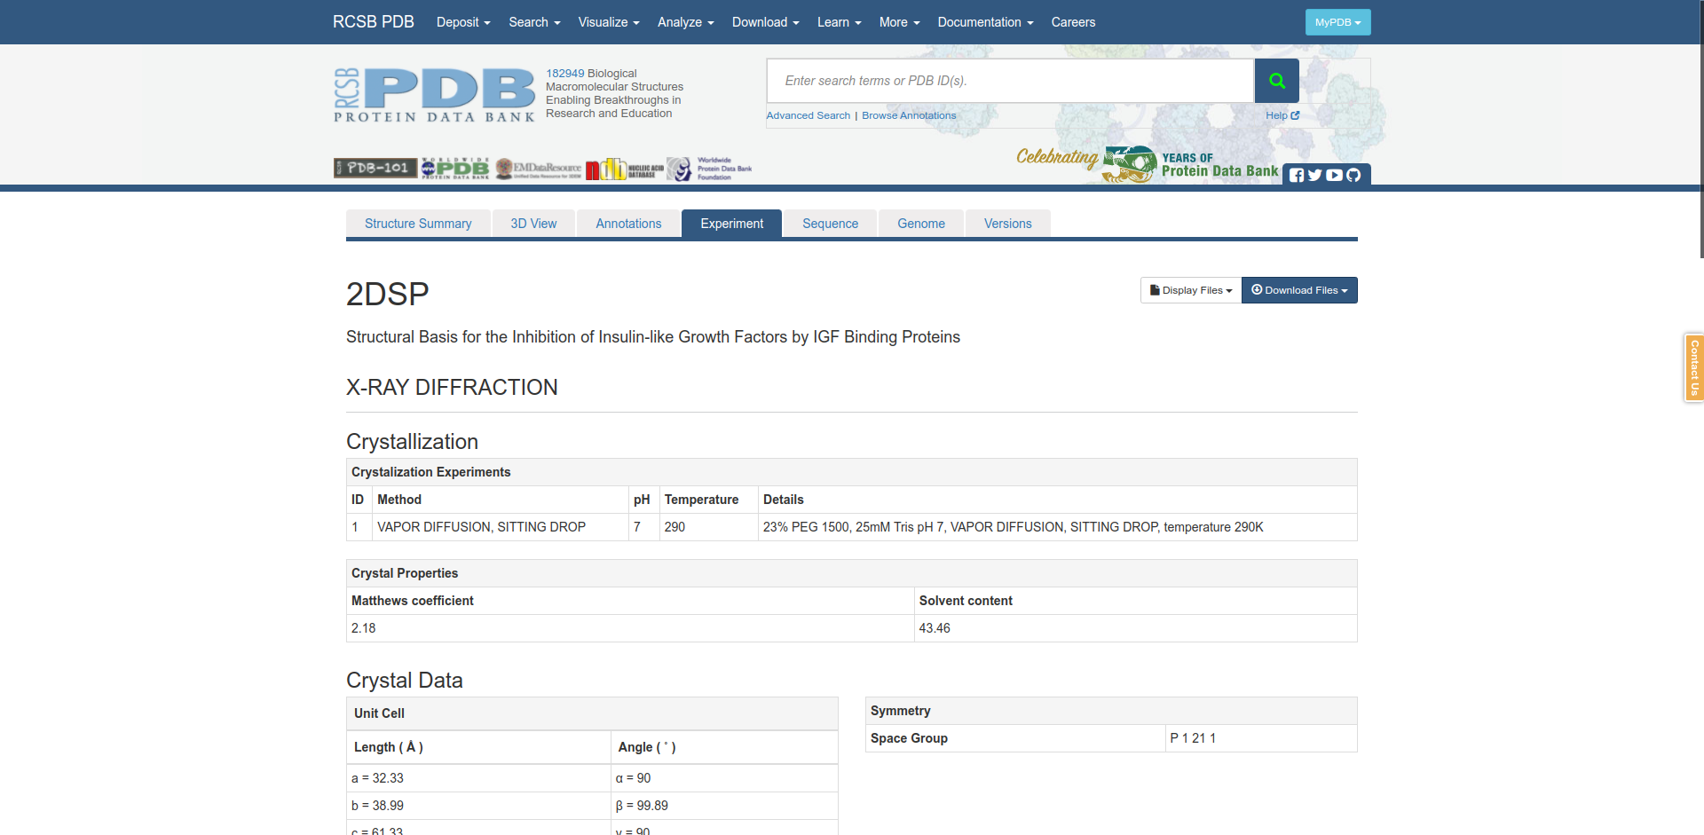
Fig6. Experiment for my query Insulin

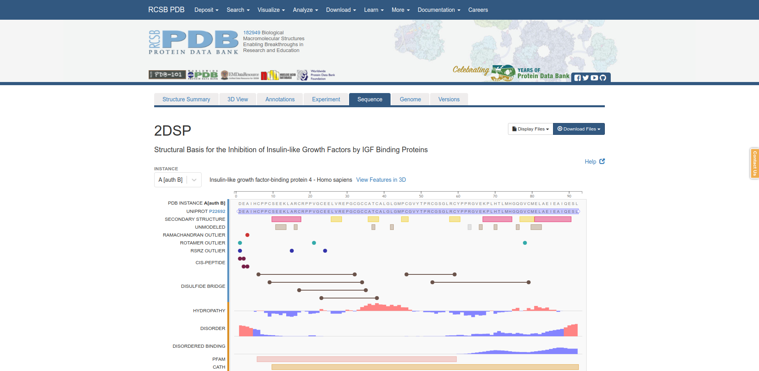
Fig7. Sequence for my query Insulin

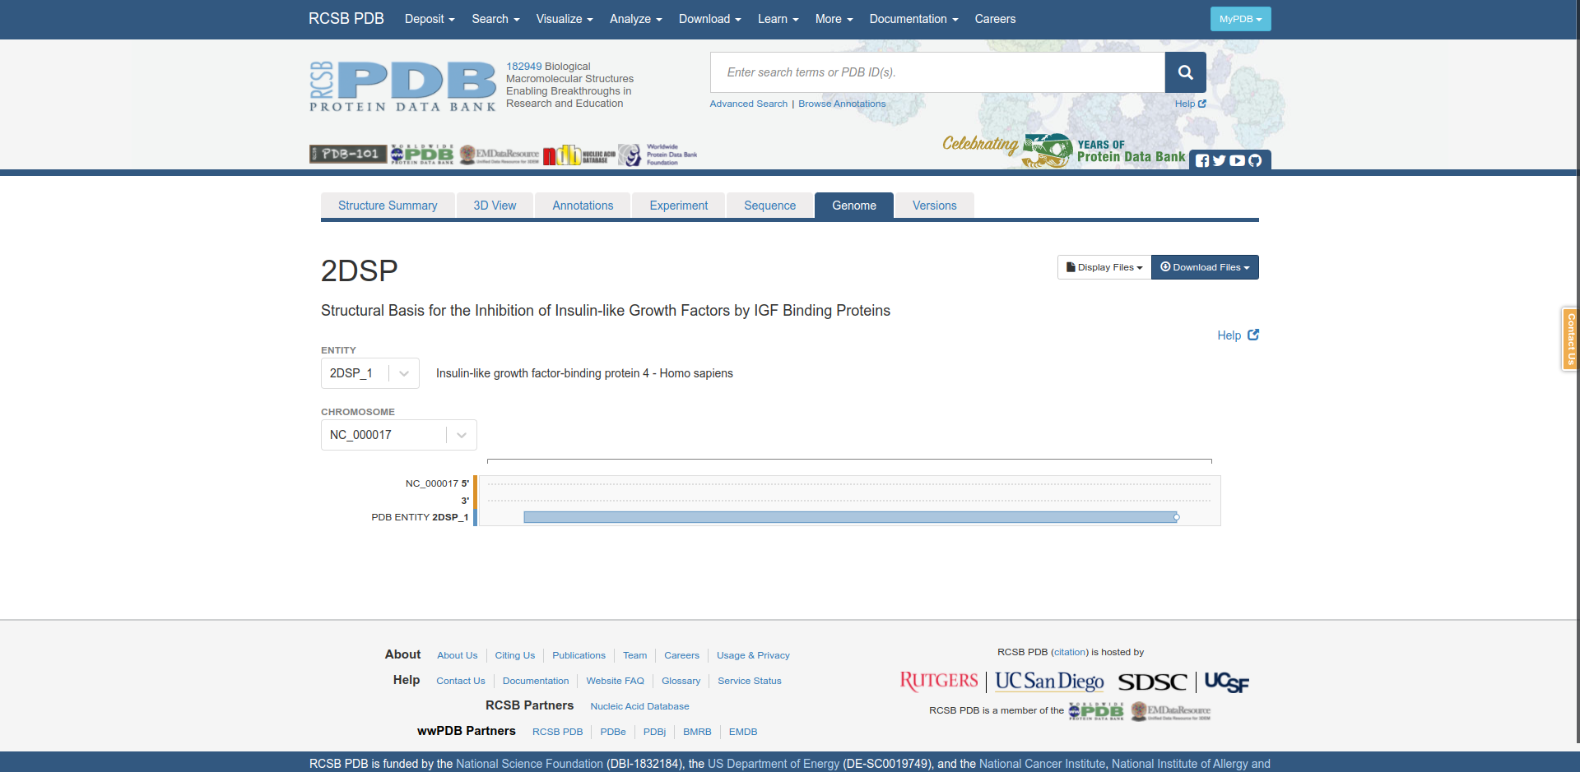
Fig8. Genome for my query Insulin

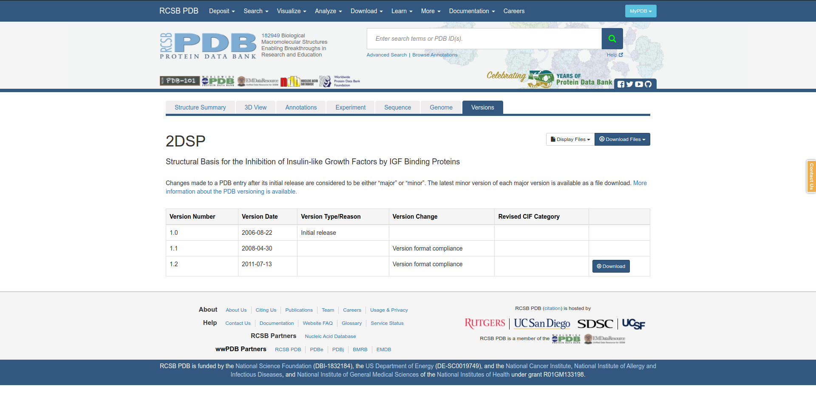
Fig9. Versons for my query Insulin

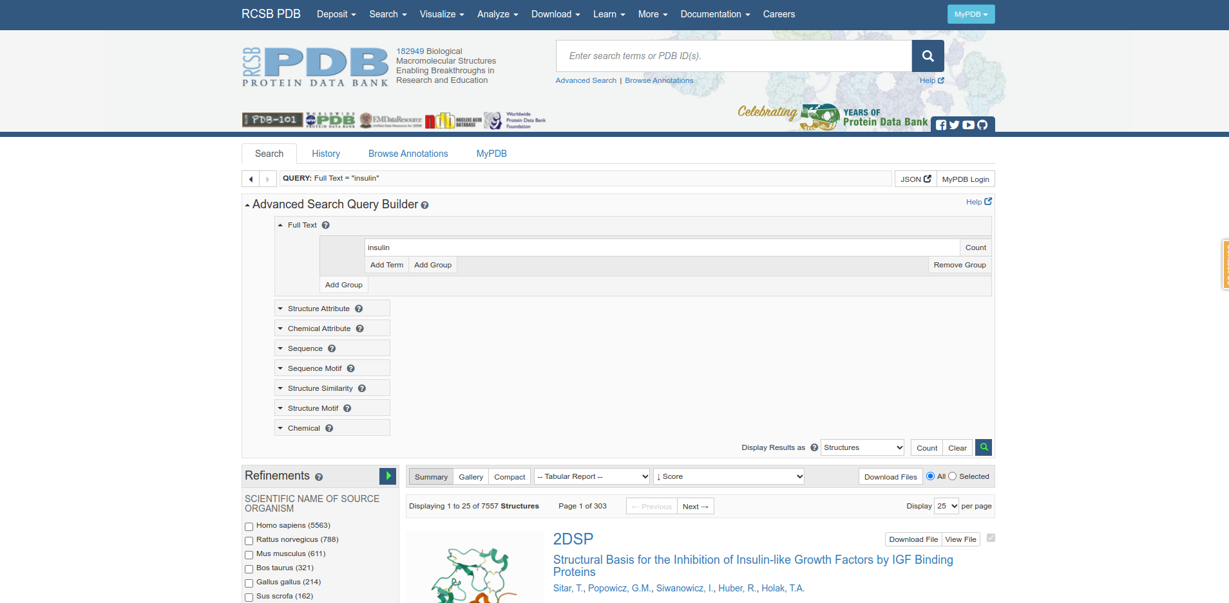
Fig10. Advanced Search query builder for my query Insulin

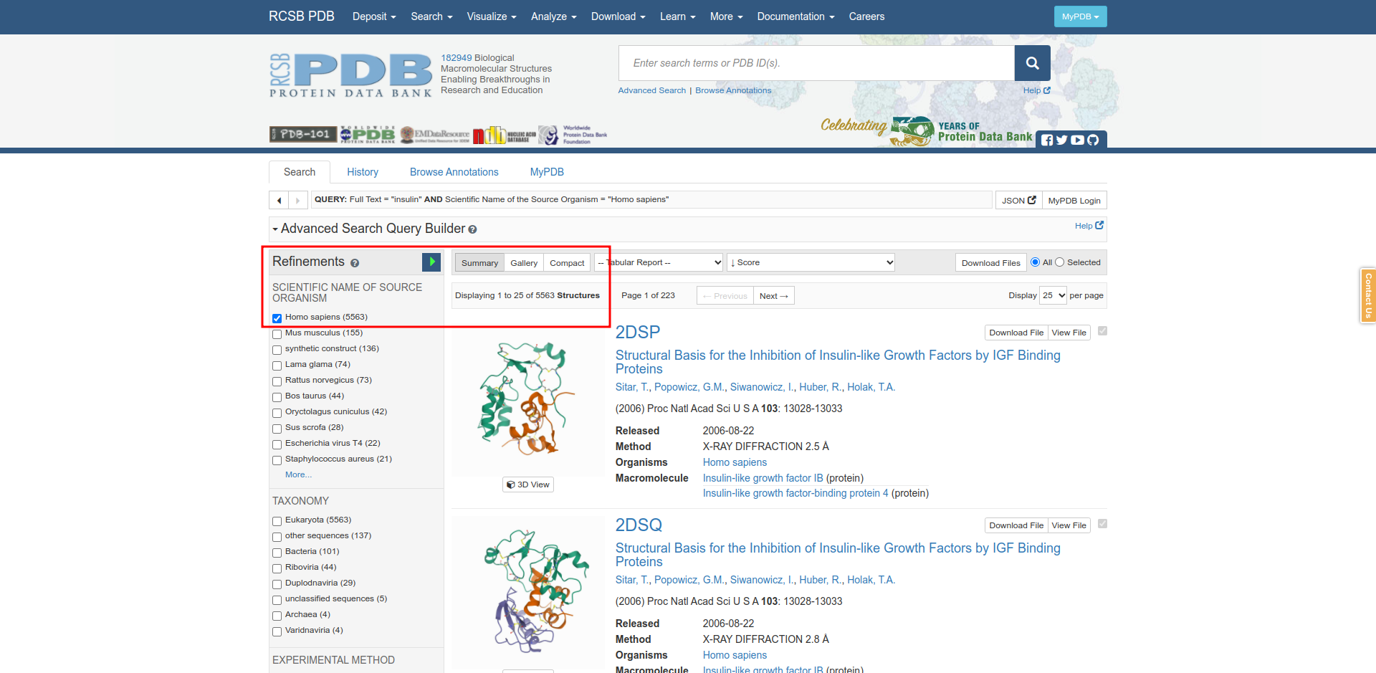
Fig11. Refinement filtering for homo sapiens for query Insulin

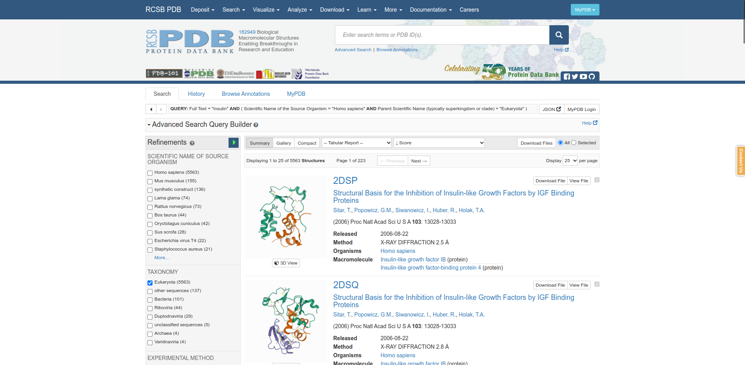
Fig12. Refinements filtering for Taxonomy Eukaryota.

Results:
Sr. No | Refinements Filter | No. of structures
1 | Unfiltered | 7557
2 | Homo sapiens | 5563
3 | Taxonomy | 5563

Conclusion:
PDB is taken care of by RCSB( Research Collaboratory for Structural Bioinformatics PDB) . PDB Form is most use & Accepted formed. Every month they upload mocelular structure. Its provides access to 3D structure data for large biological molecules ( proteins, DNA & RNA ). These are the molecules of life, found in all organisms on the planet.

References:
- Mathieu C, Gillard P, Benhalima K. Insulin analogues in type 1 diabetes mellitus: getting better all the time. Nat Rev Endocrinol. 2017 Jul;13(7):385-399
- Bank, R. P. (n.d.). Homepage. Retrieved from https://www.rcsb.org/
- Retrieved from https://www.rcsb.org/structure/2DSP
- Retrieved from https://www.rcsb.org/3d-view/2DSP
- Retrieved from https://www.rcsb.org/annotations/2dsp
- Retrieved from https://www.rcsb.org/experimental/2DSP
- Retrieved from https://www.rcsb.org/sequence/2DSP
- Retrieved from https://www.rcsb.org/genome/2DSP
- Retrieved from https://www.rcsb.org/versions/2DSP

